**Z I O N G R O V E**

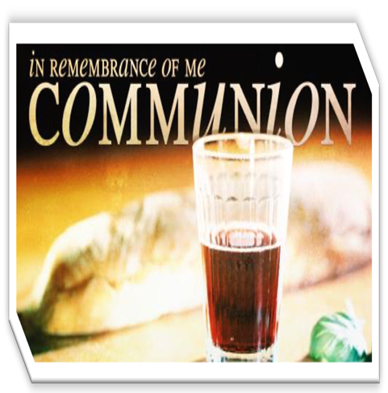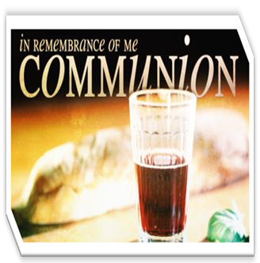

***August 3, 2025***

***Sunday School 9:20A Praise & Worship 10:15A***

***Morning Worship 10:30A Bible Study (Wed) 7P***

***Bro. Robert Hayes Staley, Supernumerary Minister***

***Rev. D. Howard Dawkins, Supernumerary Minister***

***Rev. Tami Forte Logan, Supernumerary Minister***

***Rev. Juanita Staley, Superannuated Minister***

***Rev. Earl Staley, Superannuated Minister***

***Rev. Mildred Twitty, Superannuated Minister***

***Rev. Dr. J. Ruth Davis-Shields, Pastor & PE***

**Sis. Camille C. Starnes, Missionary Supervisor**

**Bishop Darryl B. Starnes,**

**Presiding Prelate**

ORDER of WORSHIP

**The Call to Communion and Worship**

If any man sin, we have an advocate with the Father, Jesus Christ the righteous, and He is the propitiation of our sins; and not for ours only, but for the sins of the whole world. Wherefore ye that do truly and earnestly repent of your sins, and are in love and charity with your neighbor, and intend to lead a new life, following the commandments of God, and walking from henceforth in His Holy way; draw near with faith, and take the Holy Sacrament to your comfort and worship Our God in Spirit and in Truth.

**The General Confession In unison**

Almighty God, Father of our Lord Jesus Christ, Maker of all things, Judge of all men, we acknowledge and bewail our manifold sins and wickedness, which we from time to time most grievously have committed, by thought, word, and deed, provoking most justly thy wrath and indignation against us. We do earnestly repent and are heartily sorry for these our misdoings; the remembrance of them is grievous unto us. Have mercy upon us, have mercy upon us, most merciful Father, for Thy Son, our Lord Jesus Christ sake, forgive us of all that is past and grant that we may ever hereafter serve and please Thee in newness of life, to the honor and glory of Thy Name, through Jesus Christ our Lord. Amen.

**The Morning Hymn**

**The Morning Prayer**

**The Affirmation of Faith**

I believe in God the Father Almighty, Maker of Heaven and Earth; And in Jesus Christ His only Son, our Lord, who was conceived by the Holy Ghost, Born of the Virgin Mary, suffered under Pontious Pilate; Was crucified dead and buried: The third day He arose from the dead; He ascended into Heaven, and sitteth on the right hand of God, the Father Almighty; From thence He shall come to judge the quick and the dead. I believe in the Holy Ghost; the Holy catholic church; the Communion of Saints; the forgiveness of sins; the resurrection of the body; And life everlasting. Amen.

**The Prayer of Pardon**

Almighty God, our Heavenly Father, Who of Thy great mercy hast promised forgiveness of sin to all them that with hearty repentance and true faith turn unto Thee, have mercy upon us, pardon and deliver us from all our sins, confirm and strengthen us in all goodness, and bring us to everlasting life through Jesus Christ our Lord. Amen.

**The Collect for Purity In unison**

Almighty God, unto Whom all hearts are open, all desires known, and from Whom no secrets are hid, cleanse the thoughts of our hearts by the inspiration of thy Holy Spirit, that we may perfectly love Thee, and worthily magnify Thy Holy Name, through Jesus Christ our Lord. Amen.

**The Announcements & Recognition of Guests**

**The Pastor’s Briefs**

**The Selection**

**The Presentation of Gifts/Offertory**

**The Preparational Selection**

**The Communion Meditation Dr. J. Ruth Davis**

**The Call to Christian Discipleship & Altar Prayer**

**The Communion Hymn & Table Gathering**

**The Prayer of Humble Access**

**The Prayer of Consecration**

**The Sursum Corda & Sanctus with Preface**

It is very meet, right, and our bounden duty, that we should at all times, and in all places, give thanks, to Thee, O Lord, Holy Father, Almighty, Everlasting God. Therefore, with angels and archangels, and all the company of heaven, we laud and magnify thy glorious name evermore praising thee and saying, Holy, Holy, Holy, Lord God of hosts, heaven and earth are full of thy glory. Glory be to thee, O Lord most high. Amen.

**The Administration of Elements**

**The Lord’s Prayer /The Prayer of Thanksgiving**

**The Gloria in Excelsis**

Glory be to God on high, and on earth, peace , goodwill toward men! We praise thee, we bless thee, we worship thee, we glorify thee, we give thanks to thee for thy great glory, LORD God, heavenly king, God the Father Almighty! O, LORD, Lamb of God, son of the Father, that takest away the sins of the world, have mercy upon us. Thou that takest away the sins of the world have mercy upon us, have mercy upon us. Thou that takest away the sins of the world have mercy upon us, receive our prayer. Thou that sittest at the right hand of God the Father, have mercy upon us. For thou only art holy, thou only art the LORD; thou only, O Christ, with the Holy Ghost, are most high in the glory of God the Father. Amen.

**The Fellowship Hymn “What a Fellowship”**

**The Benediction**

**

**When you pray, please remember….**

John H. Staley, Bruce Payne, Ben Moore,

Virginia Ray, Herb Avery, LaFonzo Smith

**All God’s Children**

**Dates to Remember**

August 2 1st Quarterly Conference

August 31 HD Fifth Sunday Fellowship at Union Hill

Sept. 6 1st Check-Up Meeting, Walls-Battle Conf. Ctr.

**ZG Notes**

* Zion Grove Bible Study Wednesdays Zoom 7pm
* Love & Care Hour Tuesdays 10am
* Prayer Time: 2nd Sunday of the month at 9am ZG conference room. Tuesdays after the 2nd & 4th Sundays 7pm via Zoom
* Zion Grove encourages everyone to take an active part in ministry. There is a place for you. The ministries presently offered include inreach to outreach evangelism, age-related areas from children to seniors, Christian Education, Missionaries, music, and technology.
* Trustee of the Month: **Mr. John H. Staley**

**AUGUST BIRTHDAYS**

02-Jocelyn Gossett 22-Aidan Wood

02-La’Shea Morris-Davis 24-Glacia Staley

05-Sophia Staley 26-Angela Staley

06-Taylor Price 29-Makiah Staley

22-Lindsey Briscoe 30-Rev. William Eric Staley

22-Blakely Briscoe 30-Saif Davis

31-Shayla Williams

**______________________________________________**

**Living My Best Life** **Bible Study Lesson Plan**

**Relationship with God**

**A: Love God First -**Matthew 22:37–38

**Focus:** Make God the central love in your life.

**Question:** What competes for your affection more than God?

**Journal:** List 3 ways to show love for God this week.

**B: Seek God's Will -**Romans 12:1–2

**Focus:** Know God’s plan through prayer and surrender.

**Question:** Are you actively seeking God’s will?

**Journal:** Where do you need clarity from God?

**C: Obedience and Surrender -**Luke 22:42

**Focus:** Trust God’s path.

**Questions:** What has obedience cost you?

What did you gain?

**Journal:** Areas where you struggle to surrender.

___________________________________________

Join me in supporting Zion Grove A. M. E. Zion Church. It's really easy through @Givelify <https://giv.li/oxwk6h>

Let's do #MoreGoodTogether.